

Battle
Sweeper
Table of Contents
Design Brief 3
Aim 3
Objectives 3
Detailed Design 4
Sketch of all the screens that will appear 4
Specifications 5
Basic Functionality 5
Limitations 6
Input, Process, Output Table 6
Input 6
Process 6
Output 6
Context diagram 8
Data flow diagram 8
System Flowchart 9
Structure chart 9
Logbook and Gantt Chart 10
Logbook 10
14th of May 10
15th of May 10
17th of May 11
19th of May 11
20th of May 12
22nd of May 13
23rd of May 13
26th of May 14
27th of May 14
28th of May 15
29th of May 15
30th of May 16
31st of May 16
3rd of June 17
4th of June 17
5th of June 17
6th of June 18
7th of June 18

Design Brief

Aim
BattleSweeper aims to be a nostalgic but fresh and engaging past-time video game that aims to expand the appeal of Battleships and Minesweeper to a broader audience by combining the best elements of both placing down, protecting battleships, and clearing mines, allowing the game to challenge and entertain players. It aims to teach players a different type of perspective to the mechanicals within the two classic games that this game is inspired by (Battleship and Minesweeper) by stimulating critical thinking, strategic planning, problem-solving skills, etc. through its gameplay while also providing stress relief and a chance to develop patience through the methodically clearing areas and strategizing moves. BattleSweeper's aim is to be able to code a program that harmonizes both the elements of battleship and minesweeper but also make it simple enough that users will not be confused by the mechanicals of the game. Battlesweeper is a suitable project that is complex in nature but can be completed within the development period where it educational endeavor can help me learn how to tackle integrating two separate game functionalities into a whole functioning game and also how to create an efficient UI and create documentation such as user and technical manual without confusing the user and/or future developers

Objectives
The objective of this project is to first create a base Gui of Minesweeper within the multi- purpose 2D/3D engine, Godot and implement a tweaked version of Minesweeper’s auto mine assignment functionality and the “number of touching mines'' functionality into system before integrating the Battleships’ functionality of placing down ships in valid tiles. When that is finished, coding of the modules unique to this game such as calculating explosion radius, score handling and destructions of ship parts will be completed next. After that, testing will be done to find errors and bugs that will be patched out as soon as they are discovered before the game is published for people to play. The object of this game for the user is to clear out endless levels of auto generated mines while making sure that if a mine were to explode it does not end up damaging the ships that they placed

Detailed Design

Sketch of all the screens that will appear
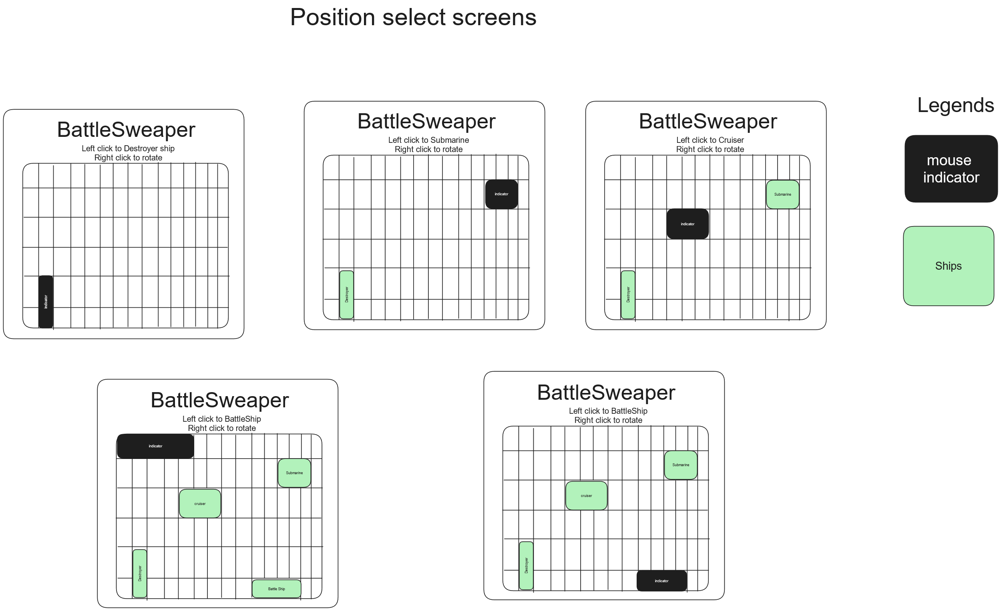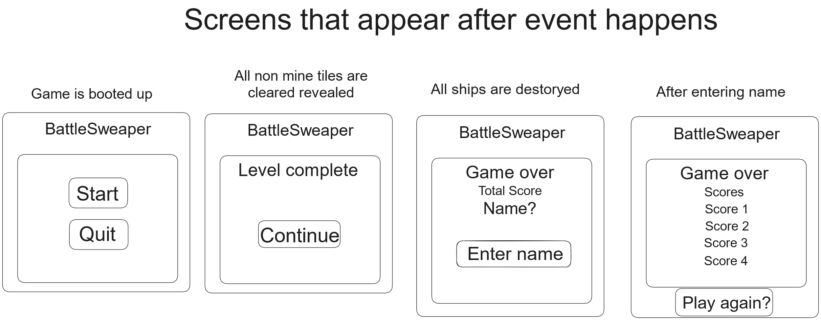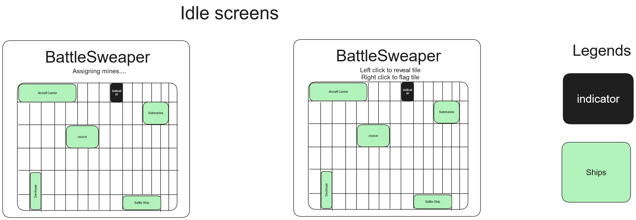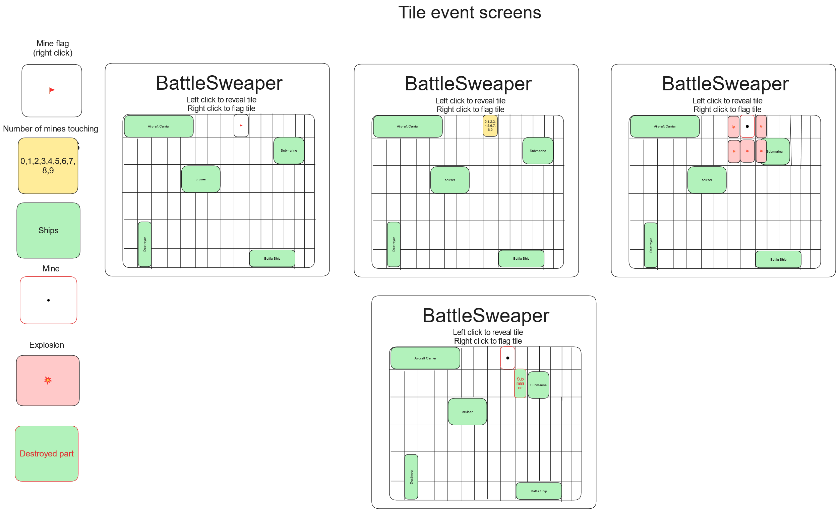

Specifications

Basic Functionality

Users are to place their existing ships on the tiles before the game auto-generates mine placements in places which are not occupied by ships. If a mine were to explode, a radius of explosion will be calculated and if it touches the ship, it will damage the part that touched the explosion. This will repeat through all levels until all the ships are destroyed which will end the game and will prompt the player to enter a name before saving their name and score in a separate file before displaying the leaderboard of previous scores.

Limitations
The game can be limited or may have its functionality hindered if the computers cannot download or execute files, do not have enough memory to efficiently run on the game, does not allow utilization of keyboards and mouse or does not have the font that is used installed. The game is intended to be played on Microsoft Windows Operating System (OS) as it will be compiled into a .exe file which other OSs may have trouble with and can run into errors trying to execute this game. Language accessibility is limited to only English, and it is limited to players who do not have a disability that impairs vision or prevents interaction with hardware

Input, Process, Output Table

Input | Process | Output
“Start” or “Play again?” Button | - Create grid tile board  - Set score to 0  - Set all ship parts to “not destroyed”  - Display prompt for player to place the first ship | “Left click to place <ship name> ship  Right click to rotate”
“Continue” Button | - Reload grid tile board  - Display prompt for player to place the first ship | “Left click to place <ship name> ship  Right click to rotate”
Ship placement | - Check if ship can be placed in valid tiles  - If ship cannot be placed  Play “error” sound  Else  - Assign ship position on tiles  - Display prompt for player to place the next ship | *Error sound*  “Left click to place <ship name> ship  Right click to rotate”
Final ship placement | - Check if ship can be placed in valid tiles  - If ship cannot be placed  Play “error” sound  Else  - Assign ship position on tiles  - Display prompt for player to place the next ship  - Display “Assigning mines….”  - Randomly assign mines to unoccupied tiles  - Display prompt for player to reveal a tile | *Error sound*  “Left click to place <ship name> ship  Right click to rotate”  “Assigning mines....”  “Left click to reveal tile  Right click to flag tile”
Revealing a non-mine tile | - Reveal tile  - Display tile number if applicable  - If adjacent tile to click tile does not have a number  Reveal tile  Repeat until tile with number is revealed  - Validate if all non-mine tiles are revealed  - If all non-mine tiles are revealed  Display “Level complete!!” | “1,2,3,4,5,6,7,8,9” on tile  “Level complete!!”
Revealing a mine tile | - Reveal mine  - Play “explosion” sound  - Calculate radius  - Display explosion emoji on tiles  - If explosion radius hits part of ship  set ship part for affected ship as “destroyed”  display part destroyed decal | *Explosion sound*  💥 on tile  *Part destroyed decal* on affected ship
Player Name | - Write on new line “<inputted name>, score” to “scores” file  - Read “scores” and display top 5 scores with names on each new line | “Score 1  Score 2  Score 3  Score 4  Score 5”

Context diagram
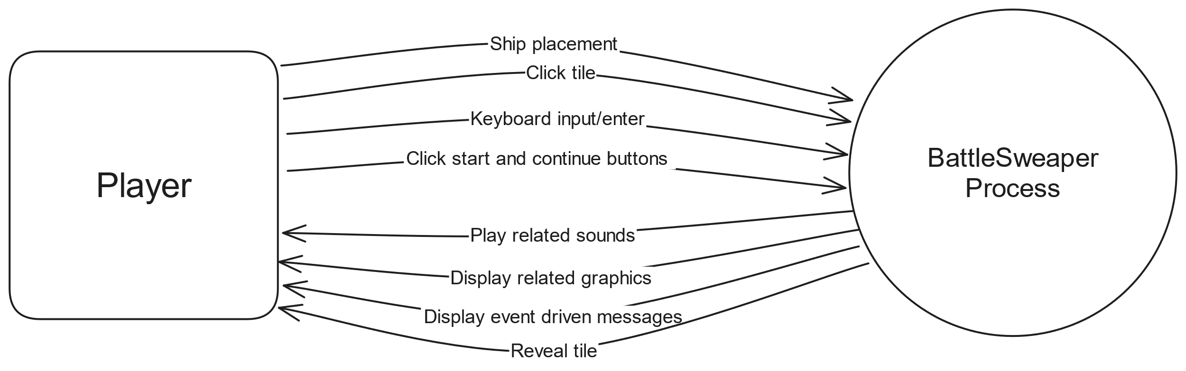

Data flow diagram
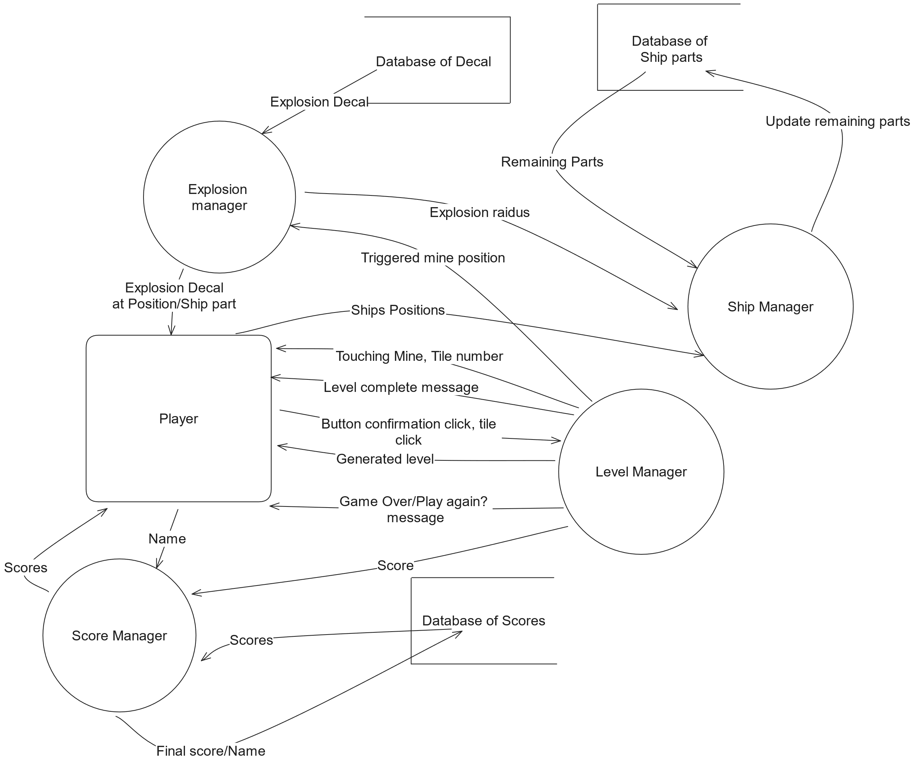

System Flowchart
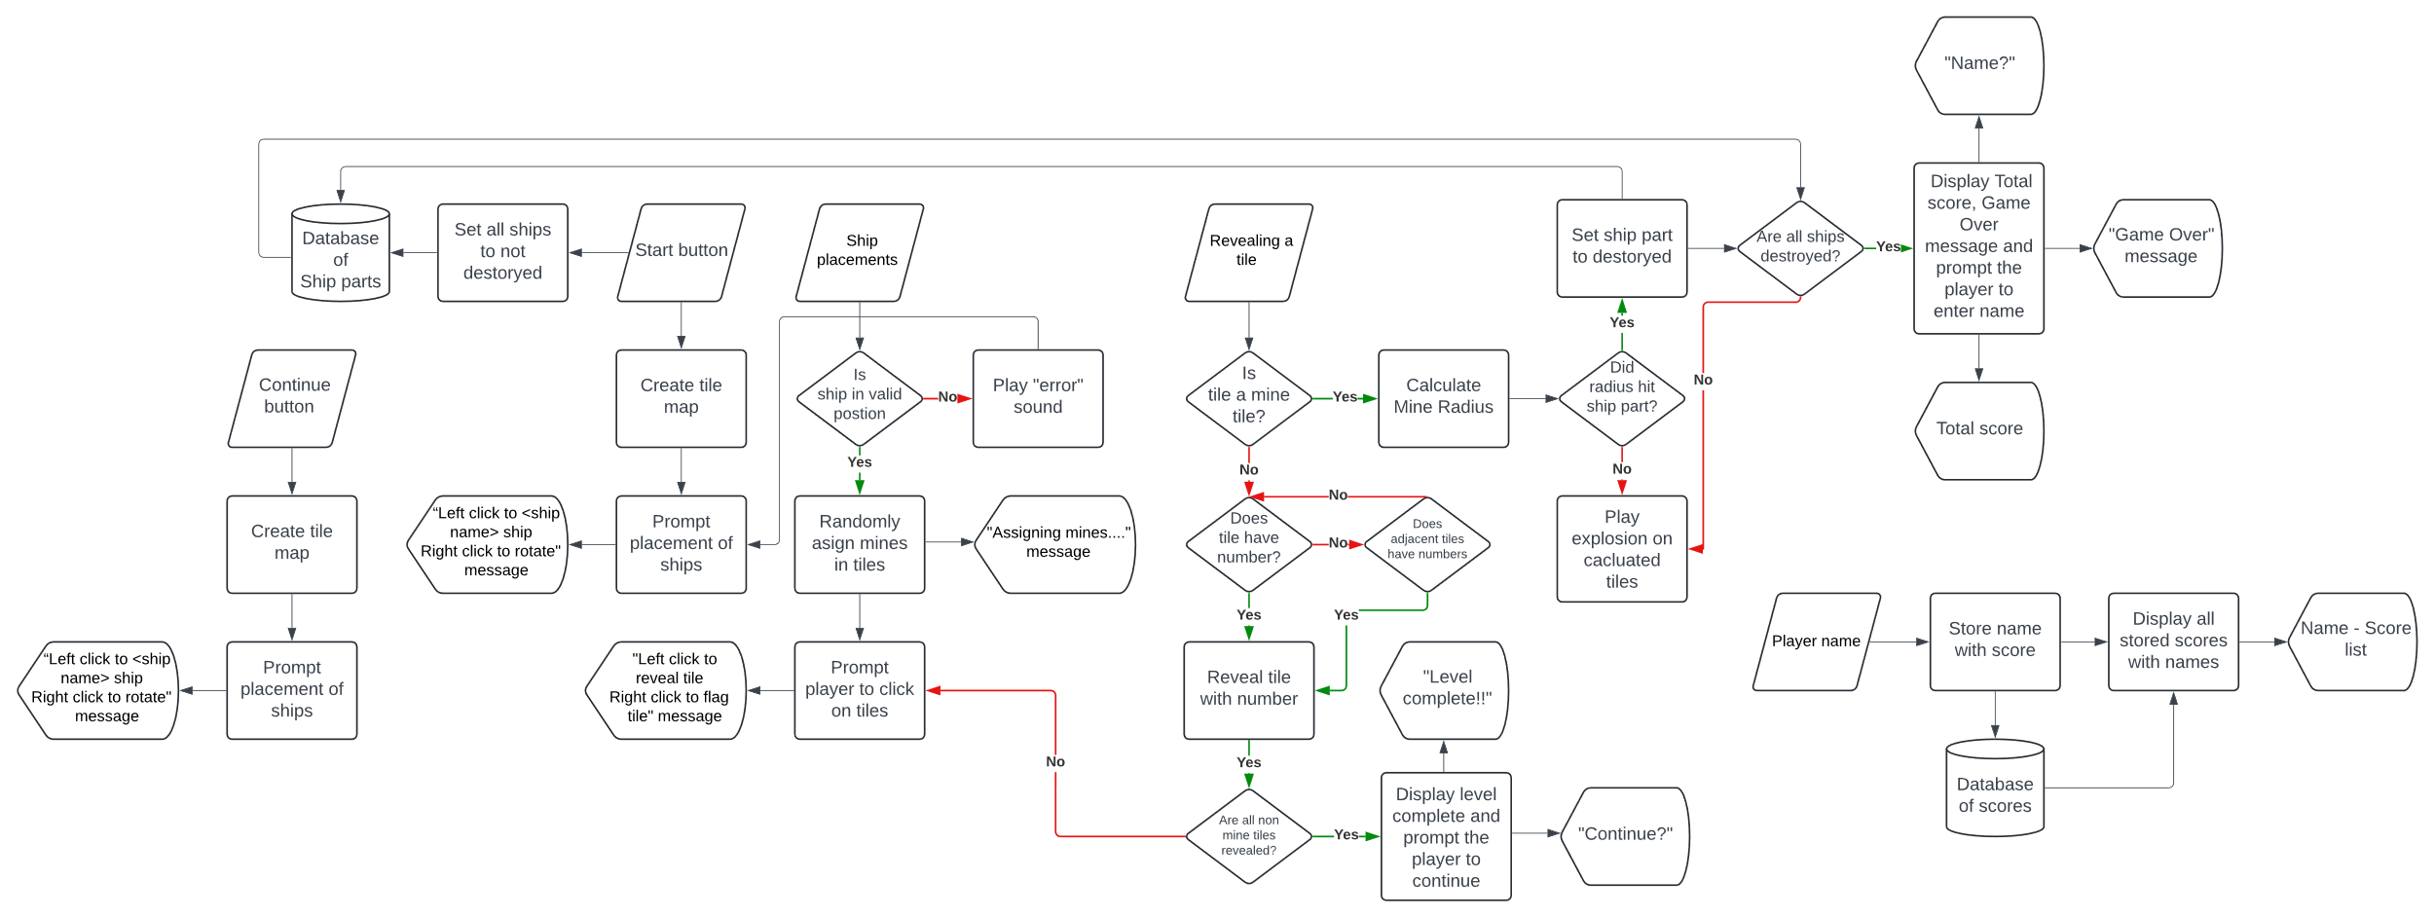

Structure chart

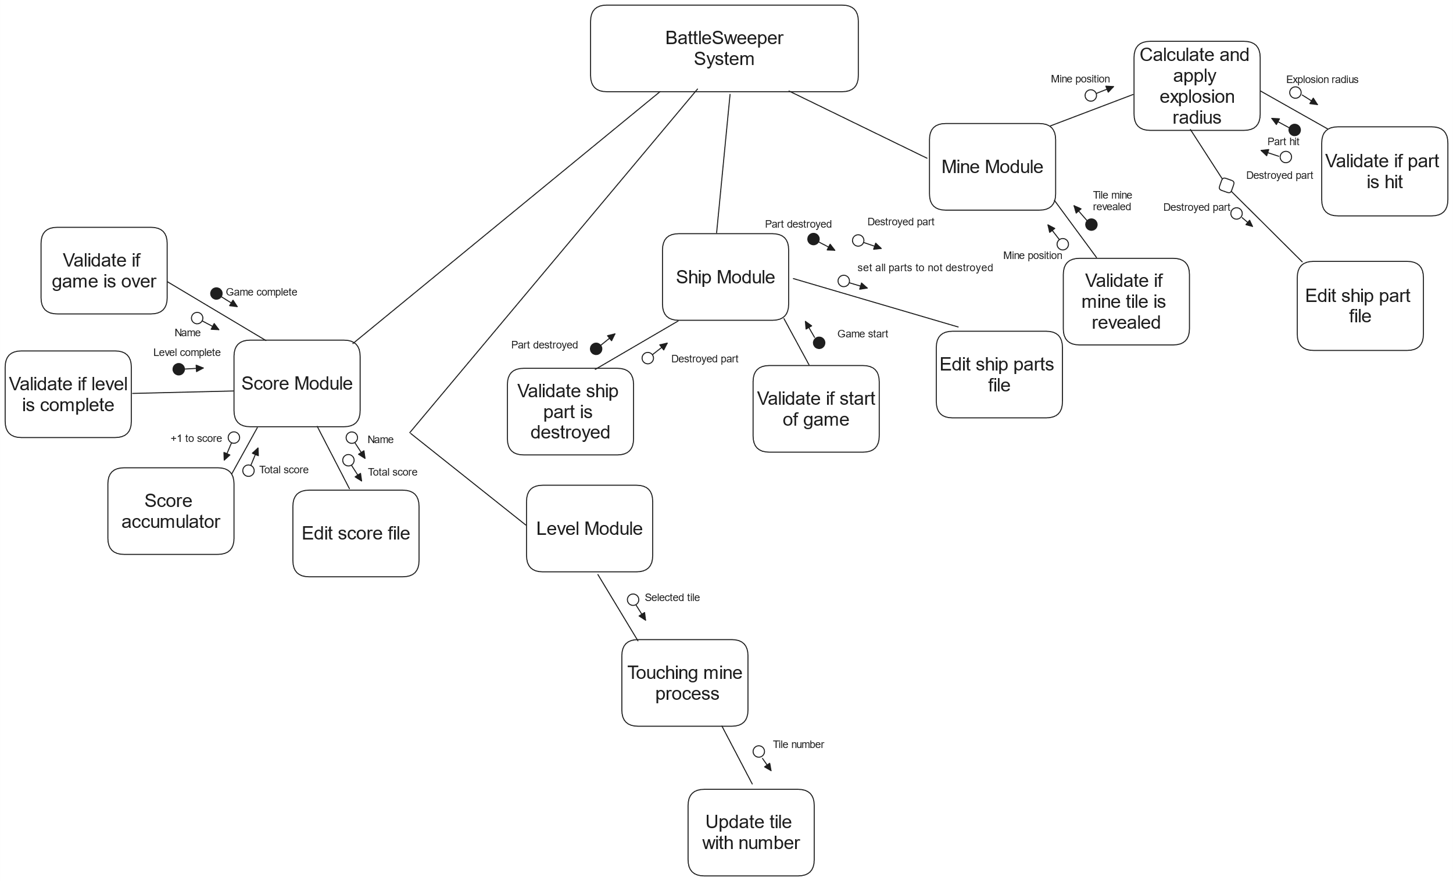

Logbook and Gantt Chart

Logbook

14th of May
- Began drafting out Design brief
  - Finished draft Design brief
    - Requires refinement of objectives
- Began drafting out Detailed design
  - Drafted out:
    - Context diagram
      - Requires addition of additional data arrows
    - Data flow diagram
      - Requires refinement of additional data arrows
      - Requires simplification of process
    - Sketch of all screens
      - Requires addition of additional screens
- Additional task for tomorrow
  - Create and finish Gantt Chart
  - Create and begin Logbook

15th of May
- Refining Detailed design
  - Refined:
    - Sketch of all screens
      - Added “submitting name for final score” screen
- Started creating logbook
- Started creating Gantt chart
  - Gantt chart finished
- Gantt Chart Progress check
  - Design Brief
    - On Course
    - Specifications
    - On Course
  - Charts
    - On course
  - Documentation
    - On Course
- Additional task for tomorrow
  - Refining Charts

17th of May
- Refinement of Design brief
  - Actually added an objective section
    - Finalized objective section
  - Added title
    - Aims
    - Objectives
  - Drafted Objectives
- Fixed error in Gantt chart
  - Only included 10 weeks
    - Resulting in underestimating everything
- Edit Gantt chart
    - Addition of
    - Topics
      - Screen Sketches
    - Titles
      - Defining and understanding the problem
      - Planning and Designing
      - Implementing
      - Testing and Evaluating
  - Change position of a few parts
- Looked into HTML x Python
  - Found library, Flask
    - Did some research into Flask
      - With ChatGPT
- Gantt Chart Progress check
  - Design Brief
    - On Course
    - Specifications
    - On Course
  - Charts
    - On course
  - Documentation
    - On Course
- Additional task for tomorrow

19th of May
- Completion/Refinement of Design brief
  - Refined:
    - Objectives
      - Added objectives of players within the game
- Gantt Chart Progress check
  - Design Brief
    - Completed
    - Specifications
    - On Course
  - Charts
    - On course
  - Documentation
    - On Course
- Additional task for tomorrow
  - Being specification

20th of May
- Reconsidered use of flask
  - Flask is not great at making game interfaces
  - Considering if pygame should be used to make Gui
    - library is designed to make games
- Researched PyGame library
  - Consider use to create a game since it has
    - Has a well-documented game development framework
    - Easy and versatile to make games with GUI with
      - With chat GPT and internet
  - PyGame Documentation
    - https://www.pygame.org/docs/
- Begin drafting specifications
  - Complete draft of Basic Functionality of game
  - Completed draft of Limitation
    - Researched points of limitation with ChatGPT
- Gantt Chart Progress check
  - Specifications
    - On Course
  - Algorithm
    - Not started
  - Charts
    - On course
  - Documentation
    - On Course
  - Coding
    - Not started
- Additional task tomorrow
  - Begin IPO table

22nd of May
- Refined specifications
  - Finished Basic functionalities
- Reordered headings
  - “Specifications” are under “Sketch of all the screen...”
- Added new heading
  - Input, Process, Output Table
    - Drafted Input, Process, Output Table
      - Completed Input, Process, Output Table draft
- Gantt Chart Progress check
  - Specifications
    - On Course
  - Algorithm
    - Not started
  - Charts
    - On course
  - Documentation
    - On Course
  - Coding
    - Not started
- Additional task tomorrow
  - Edit existing charts

23rd of May
- Refining Limitations, IPO Table, context and data flow diagram
  - Limitations
    - Added additional information about the source code being converting into object code
  - IPO Table
    - Made more concise
  - Context diagram
    - Additional data flow arrows
    - Completed context diagram
- Research Godot game engine
  - Script is like python
    - Clear documentation like PyGame
        - A lot better looking and concise
    - Has an active community
      - Research form ChatGPT
  - Consider use Godot or PyGame
- Gantt Chart Progress check
  - Algorithm
    - Not started
  - Charts
    - On course
  - Documentation
    - On Course
  - Coding
    - Not started
- Additional task tomorrow

26th of May
- Refining Data flow
  - Reduced process
  - Added additional data arrows
- Gantt Chart Progress checks
  - Algorithm
    - Behind on schedule
  - Charts
    - On course
  - Documentation
    - On Course
  - Coding
    - Behind on schedule
- Additional task tomorrow

27th of May
- Refining Data flow, IPO table
  - Data flow
    - Reduced process
    - Removed data arrows
  - IPO table
    - Fixed spelling
- Began drafting system diagram
- Gantt Chart Progress check
  - Algorithm
    - Behind on schedule
  - Charts
    - On course
  - Documentation
    - On Course
  - Coding
    - Behind on schedule
- Additional task tomorrow

28th of May
- Refining Data flow, IPO table
  - Data flow
    - Added data arrows
  - IPO table
    - Added process to some rows
      - “Start” or “Play again?” Button
      - Revealing a non-mine tile
- Continue drafting system flowchart
  - Added symbols
  - Added flow lines
- Gantt Chart Progress check
  - Algorithm
    - Behind on schedule
  - Charts
    - On course
  - Documentation
    - On Course
  - Coding
    - Behind on schedule
- Additional task tomorrow

29th of May
- Refining Data flow
  - Data flow
    - Removed process
    - Added data arrows
- Continue drafting system flowchart
  - Added symbols
  - Added flow lines
- Gantt Chart Progress check
  - Algorithm
    - Behind on schedule
  - Charts
    - On course
  - Documentation
    - On Course
  - Coding
    - Behind on schedule
- Additional task tomorrow

30th of May
- Refining Context, Data flow
  - Context
    - Added and removed data arrow
  - Data flow
    - Removed process
    - Removed data arrows
- Continue drafting system flowchart
  - Added symbols
  - Added flow lines
  - Completed drafting of system flowchart
- Started Structure chart draft
  - Finished the structure chart draft
- Gantt Chart Progress check
  - Algorithm
    - Behind on schedule
  - Charts
    - Completed
  - Documentation
    - On Course
  - Coding
    - Behind on schedule
- Additional task tomorrow

31st of May
- Refining Structure chart
  - Change format
  - Decide to do it after the code is finished
- Setting up environment
  - Set up Godot environment file
- Found existing minesweeper game made within Godot
  - “Minesweeper Godot”
- Gantt Chart Progress check
  - Algorithm
    - Behind on schedule
  - Charts
    - Completed
  - Documentation
    - On Course
  - Coding
    - Behind on schedule
- Additional task tomorrow
  - Begin coding

3rd of June
- Mess around with Godot
  - Watch videos (playlist) on how to make use of Godot
    - Found out visual studio has a plug in
- Gantt Chart Progress check
  - Algorithm
    - Behind on schedule
  - Documentation
    - On Course
  - Coding
    - On Course
- Additional task tomorrow
  - Begin coding

4th of June
- Setting up Godot
  - Watch videos (playlist) on how to make use of Godot
    - Learnt stuff about nodes and scene
  - Set up main stuff
- Gantt Chart Progress check
  - Algorithm
    - Behind on schedule
  - Documentation
    - On Course
  - Coding
    - On Course
- Additional task tomorrow

5th of June
- Setting up Godot
  - Watch videos (playlist) on how to make use of Godot
    - Learnt about signals
    - Learnt about effective documentation reading and forum inquiries
  - Created label on main game
- Gantt Chart Progress check
  - Algorithm
    - Behind on schedule
  - Documentation
    - On Course
  - Coding
    - On Course
- Additional task tomorrow

6th of June
- Learning up Godot
  - Watch videos (playlist) on how to make use of Godot
    - Learn more about the physics engine of Godot and properties that I can change
  - Set up main stuff
- Gantt Chart Progress check
  - Algorithm
    - Behind on schedule
  - Documentation
    - On Course
  - Coding
    - On Course
- Additional task tomorrow

7th of June
- Switched to Word
  - Fixed formatting
  - Added table of content
  - Added title page
- Refined Design Brief
  - Aims
    - Added more specific elaboration
  - Objectives
    - Replace flask with Godot
    - Changed wording
      - Made for descriptive
- Refined Sketch of all screens that will appear
  - Added legends
- Converted all image into scalable .svg images for quality
- Gantt Chart Progress check
  - Algorithm
    - Behind on schedule
  - Documentation
    - On Course
  - Coding
    - On Course
- Additional task tomorrow

9th of June
- Learning up Godot
  - Watch videos (playlist) on how to make use of Godot
    - Learnt how to read keyboard inputs
    - Learnt how to use signals
- Gantt Chart Progress check
  - Algorithm
    - Behind on schedule
  - Documentation
    - On Course
  - Coding
    - On Course
- Additional task tomorrow
  - Continue learning

10th of June
- Learning up Godot
  - Watch videos (playlist) on how to make use of Godot
    - Learnt how to make signals
      - Learnt more modern uses of signals through this video
    - Building a small tutorial game; learnt new stuff
  - Learnt about the “await” function from this video
- Gantt Chart Progress check
  - Algorithm
    - Behind on schedule
  - Documentation
    - On Course
  - Coding
    - On Course
- Additional task tomorrow
  - Continue learning

13th of June
- Learning up Godot
  - Watch videos (playlist) on how to make use of Godot
    - Building a small tutorial game; learnt new stuff
- Gantt Chart Progress check
  - Algorithm
    - Behind on schedule
  - Documentation
    - On Course
  - Coding
    - On Course
- Additional task tomorrow
  - Continue learning

14th of June
- Learning up Godot
  - Watch videos (playlist) on how to make use of Godot
    - Building a small tutorial game; learnt new stuff
- Gantt Chart Progress check
  - Algorithm
    - Behind on schedule
  - Documentation
    - On Course
  - Coding
    - On Course
- Additional task tomorrow
  - Continue learning

15th of June
- Learning up Godot
  - Watch videos (playlist) on how to make use of Godot
    - Building a small tutorial game; learnt new stuff
- Gantt Chart Progress check
  - Algorithm
    - Behind on schedule
  - Documentation
    - On Course
  - Coding
    - On Course
- Additional task tomorrow
  - Continue learning

